Date
[insert name/company name]
Thank you for your interest in Southeast Missouri State University’s 8th Dance Marathon event! We are excited to have the opportunity to continue Dance Marathon on our growing campus and offer this amazing program for all students and faculty.
Dance Marathon is a nationwide movement of college students committing to stay on their feet for twelve or more hours to raise money for Children’s Miracle Network Hospitals.
Southeast Missouri State University’s Dance Marathon will benefit Children’s Miracle Network Hospitals of Greater St. Louis, which means that the money we raise stays in our community to help local kids. All of the money we raise is split equally between St. Louis Children’s Hospital and SSM Cardinal Glennon Children’s Medical Center, helping them acquire new patient programs, equipment, and facility renovations to meet the needs of area kids.
This coming year Southeast Missouri State University will host a twelve hour dance marathon on February 22, 2014, to raise money Children’s Miracle Network Hospitals. We have set our goal to have 300 participants and to raise $15,000.00. We are confident that we will be able to go above and beyond our goals!
With the help from our community, we hope we can help make a difference in children’s lives by raising funds to put towards these amazing hospitals. Any donation, monetary and/or items, is gladly accepted.
We hope you can help us by contributing to this amazing event.
If you can help support our cause or have any questions, please contact Jessica Blansitt and/or Renee Bender, Southeast Missouri State University DM Co Chairs at jlblansitt1s@semo.edu or 314-610-9618. Thank you so much for your time and consideration.

For the Kids,
Jessica Blansitt

Southeast Missouri State University
Dance Marathon Sponsorship Levels

Miracle Partner $5,000
- All benefits of a Marathon Partner
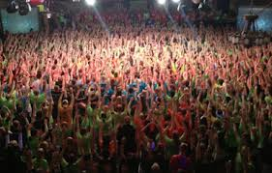
- Company name recognized on website with link
- Promotional table to distribute small products to participants at event
- Sponsorship recognition every 4 hours on jumbo screen at event
- Partnership presentation during the event

Marathon Partner $2,500
- All benefits of a Hope Partner
- Sponsorship recognition twice during event
- Partnership presentation during the event

Hope Partner $1,000
- All benefits of a Wish Partner
- Name listed on website
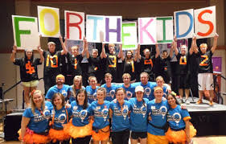
Wish Partner $500
- All benefits of a Spirit Partner
- Sponsorship recognition once on jumbo screen at event

Spirit Partner $200
- All benefits of a For the Kids Partner
- Post event Thank You on all social media

For the Kids Partner $100
- Company name on banner at marathon
- Logo on back of all dancer t-shirts

For more information, contact: Jessica Blansitt, Dance Marathon Co Chair at jlblansitt1s@semo.edu or 314-610-9618

