‘DANCER’ INFORMATION Q&A’s

Q: WHY 12-HOURS?
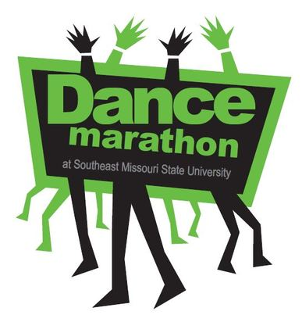
A: The 12-hours are a sign of sacrifice. We donate our time to support our Miracle Kids who have had to struggle with life-threatening illnesses and weren't always able to get up and dance. We dance for all the times they couldn't. We dance for the kids that would give ANYTHING to be...well, a kid!

Q: DOES DANCE MARATHON CONSIST OF JUST DANCING?
A: NO! There’s more to do than ‘dance’ at Dance Marathon. Our big event offers various types of entertainment! This year will include a live DJ, themed hours that you can dress accordingly to, FREE food, a PHOTOBOOTH, games, door prizes, awards and most importantly interacting with the miracle children! During the marathon you will meet new people, interact with the Miracle Children and hear from the Miracle Families you are helping, which is the greatest motivator of all. You will be surprised just how much fun you can have in 12 hours!

Q: WHAT ARE THIS YEARS THEMED HOURS?
A:

Decades Hour (70s, 80s, 90s)
Zumba
Showtunes & Movie Soundtracks
Olympic Hour
So You Think You Can Dance?
Country Hour
Celebrity
Be a Kid
Neon Hour
FTK-For The Kids Hour

Q: I NEED COMMUNITY SERVICE HOURS CAN DANCE MARATHON HELP ME OUT?
A: Of course! Dance Marathon is a great opportunity to gain community service hours. For more information contact our Dancer Relations Chairpersons: Cole Simon (chsimon1s@semo.edu)

Q: WHEN DO I NEED TO BE AT THE EVENT?
A: Check-in begins at 9am in the North Student Recreational Center. Opening ceremonies begin promptly at 10am.

At Check-in you will receive:
- A wrist-band with a Miracle Child’s Name, Age, and Diagnosis
- A ‘Take-a-Break’ Ticket
- A FREE commemorative T-shirt (if you raised $20 by Feb. 16th)

Q: CAN I STILL ATTEND EVEN IF I HAVE OTHER PLANS THAT DAY?
A: YES! Members from our planning committee will check-in dancers throughout the day.

Q: WHAT Should I Bring To Dance Marathon?
Please bring the following items at
- *Your SEMO ID to Check-In & Check-Out
- Any donations that you or your team raised! These donations will be entered in DonorDrive by our Finance Committee at the event.
- Cash to purchase merchandise
Q: What should I Leave At Home?
A: Valuables (all items you bring to the event are your responsibility!) Alcohol, drugs, tobacco or any other illegal substances

q: WHAT Should I wear at dance marathon?
A: Plan to wear
- Comfortable shoes & clothes
- Any costume changes for our themed hours!

Q: DO I HAVE TO STAY THE ENTIRE TIME?
A: You will WANT to stay the entire time! The day consists of many types of entertainment and activities. And we provide meals for lunch and dinner. Each hour participants will have the chance to win prizes &awards including; Apparel, Gifts baskets, Gift cards, St. Louis Cardinals Tickets, & MUCH more!

Q: WHAT ARE THE ‘DANCER’ INCENTIVES?
A:Throughout the day we will be announcing prize winners which include charitable donations from local businesses! These donations include gift certificates, coupons, and other merchandise.

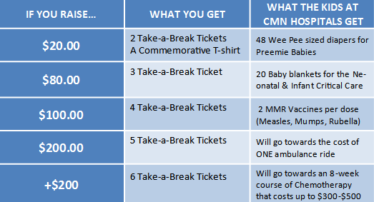
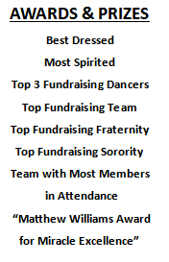
Each ‘dancer’ will be given a “Take-a-Break Ticket” at Check-in. Each “Take-a-Break Ticket” can be redeemed for a 5 minute break at any time during the event.
Every Dollar raised makes a BIG DIFFERENCE in the life of a sick kid!

